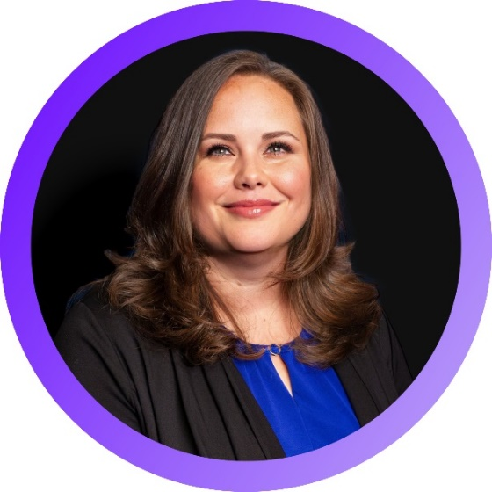**Kelly M. Caldwell, SHRM-SCP**

**Partner   
Visions Human Resources Services, LLC**

**kcaldwell@visionshr.com | (845) 567-3978**

Kelly Caldwell is a Partner at Visions Human Resources Services, LLC, a RBT CPAs affiliate, where she supports each client’s unique HR goals. Kelly has broad experience with employment law compliance; benefits and compensation; workplace culture; talent acquisition; training and development; performance management; and employee and labor relations; hiring; performance; investigations; and terminations.

Before joining Visions Human Resources Services, Kelly was Human Resource Director at Onondaga Employee Leasing Services, Inc. (OELS). She was responsible for all HR activities and a team of managers and licensed/certified individuals who provided outsourced benefit administration, employee relations expertise, labor law compliance consultation, and human resources information systems (HRIS) support for 240 clients spanning a variety of industries. Prior to OELS, Kelly worked for Rondout Savings Bank in both retail banking and HR, and Best Buy Company, Inc. as a corporate project manager.

Kelly graduated from SUNY Ulster with an A.S. in Individual Studies; earned a Paralegal certificate from Marist College; and received a Certificate in Leadership from The Chamber Foundation, Inc.

**Professional/Industry/Community Affiliations:**

• Society of Human Resource Management (SHRM), Mid-Hudson Chapter President; New York State Council Member; Insights Panel Member

• Dutchess County Regional Chamber of Commerce, Women’s Leadership Alliance (WLA) Committee Member; Business Education Committee Member

• Ulster County Regional Chamber of Commerce Member

• Orange County Chamber of Commerce Member

• International Public Management Association for Human Resources (IPMA), Member

• College and University Professional Association for Human Resources Member

• Association of Junior Leagues International, Kingston Chapter Member

• Kiwanis International, Kingston Chapter Member

**Licenses/Certifications:**

• Senior Certified Human Resource Professional (SHRM-SCP)

• Notary Public, New York State